**Login/Register**

The login page is used to connect the user’s account with the application. On this page the user will be prompted to input their username and password. If the username and/or password is not correct. A message will be shown to the user to alert the user that the credentials is invalid. The user will now be able to access their accounts with the given credentials.

If the user does not have an account, they will be prompted to create a firebase account. This signup sheet will prompt a username and email, and if the details are valid, an account will be created and a message shown to alert the user.

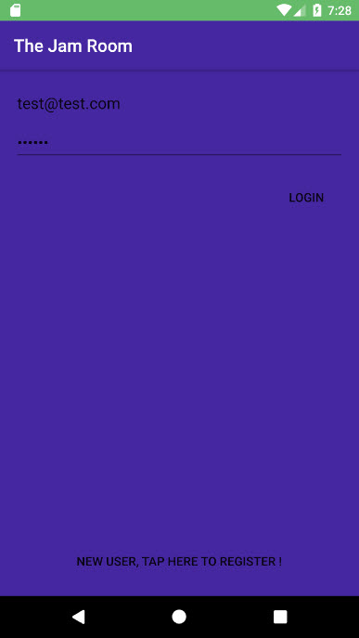

When the app starts up for the first time the user will be greeted with a login scree.

The login screen will ask for the users TheJamRoom email address and password.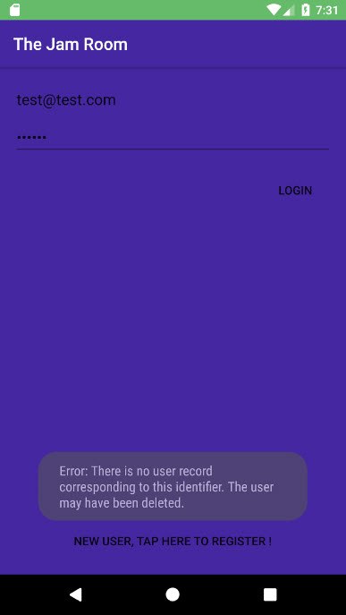

When the users enters a incorrect email or password this error message appears.

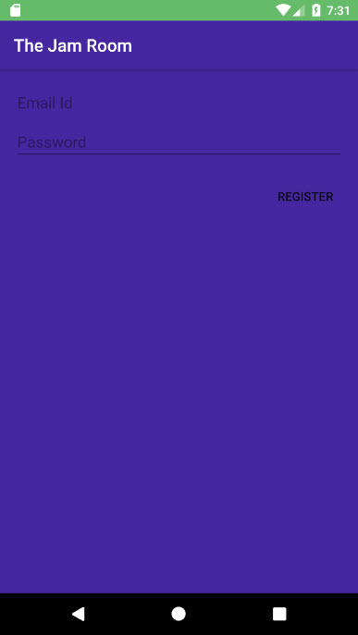

If the user is not yet registered on our TheJamRoom website, the app will give them a chance to create a partial account.

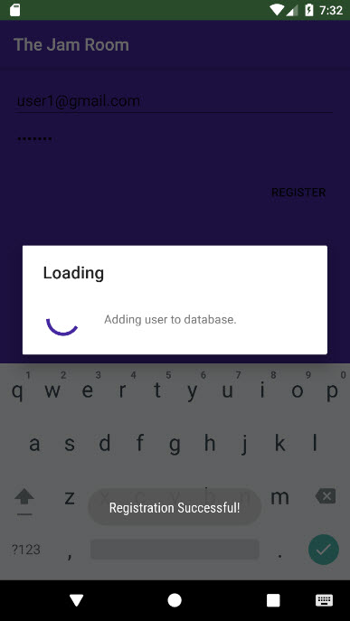

When the user entered his credentials correctly the app will display a message.

**Messaging**

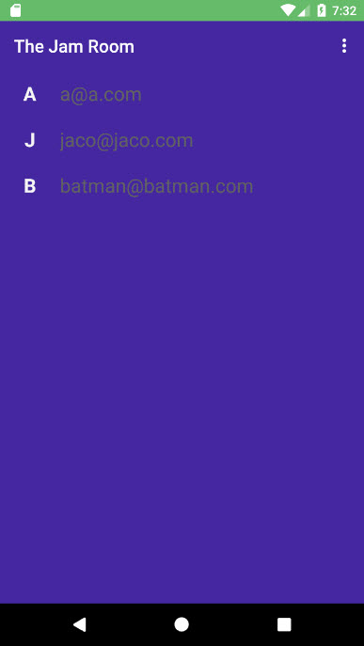

Once the user is inside his profile he will be redirected to his messaging page displaying his available contacts.

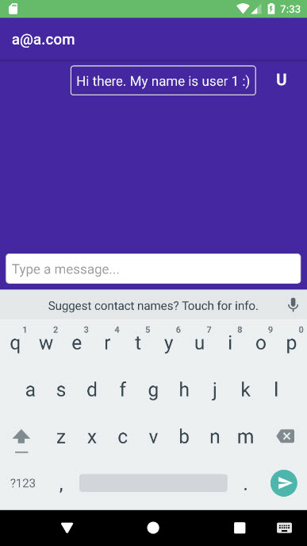

Here user 1 sent user [a@a.com](mailto:a@a.com) a message.

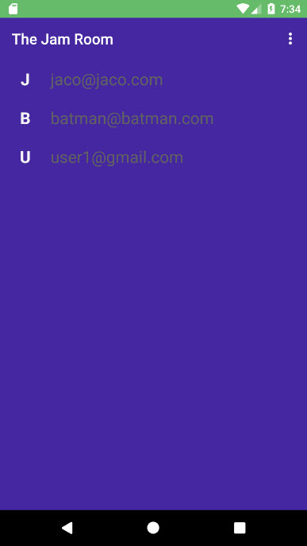

Here user a@a can view his available friends to message.

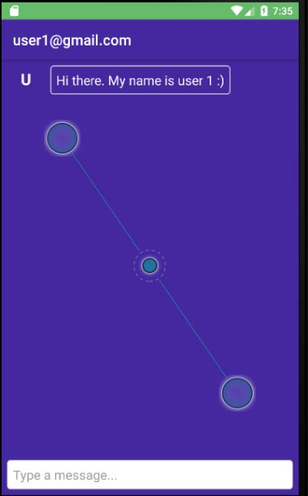

User 1’s messaged was received successfully.

